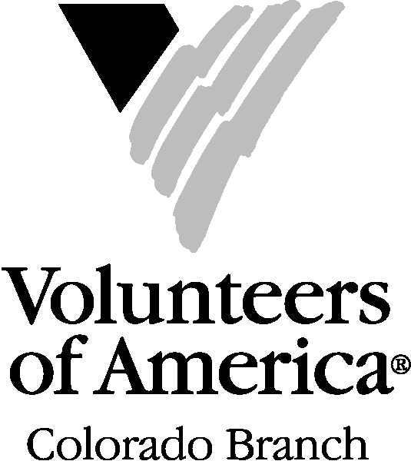

PARENTAL CONSENT FORM

Your child would like to become a Youth Volunteer with Volunteers of America. Before she/he can begin, your consent is necessary to ensure participation. Please read the following statements and sign below.

In consideration of being granted permission to volunteer for Volunteers of America, or any of its entities, on behalf of myself and my heirs, executors, administrators and assigns, hereby release Volunteers of America, its separate entities, agents, employees and officers from any claim for injuries my child may incur of any kind, at any time, whether known or unknown, caused by or related to my child’s volunteer work.

I further agree to indemnify Volunteers of America and/or any of its separate entities, against all claims, demands, actions, judgments and executions that Volunteers of America and/or its separate entities may sustain as a result of, or arising from my child’s actions as a volunteer, whether or not such claims, demands, actions, judgments and executions are discovered during the period of my child’s volunteer work.

Name of Youth Volunteer:

I understand that my child will be performing volunteer work and I hereby give my permission for her/him to serve in that capacity. I understand that she/he will be provided with an orientation and training necessary to perform the volunteer work. I hereby consent and agree to the use of any photographs, film or video of my child for advertising or publicity purposes by the Volunteers of America. I waive all claims for any compensation for such use.

Parent/Guardian Signature: ____________________________________________

Address:

City: State:_______ Zip Code:

Emergency Phone Number:

(Fall 2017)

