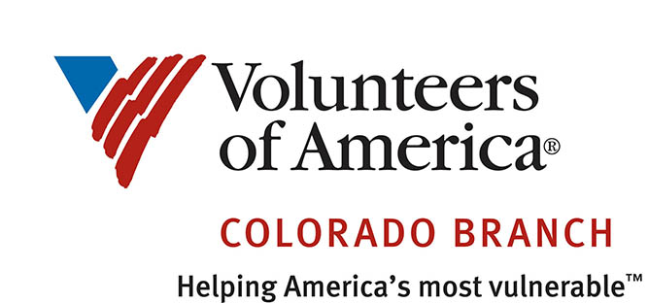

RELEASE OF CLAIMS AND AGREEMENT
TO INDEMNIFY VOLUNTEERS OF AMERICA

In consideration of being granted permission to volunteer with Volunteers of America or any of its entities, I, on behalf of myself and my heirs, executors, administrators and assigns, hereby release Volunteers of America, its separate entities, agents, employees and officers from any claim for injuries I may incur of any kind, at any time, whether known or unknown, caused by or related to my volunteer work, which is not caused by the negligence of Volunteers of America, its separate entities, agents, employees or other volunteers.

I further agree to indemnify and hold harmless Volunteers of America and/or any of its separate entities, against all claims, demands, judgments and executions that Volunteers of America and/or its separate entities may sustain as a result of, or arising from my actions as a volunteer, that are beyond the scope of my assigned volunteer duties, whether or not such claims, demands, actions, judgments and executions are discovered during the period of my volunteer work.

I, _________________________________________(Printed Name) certify that I have read and understand this Release of Claims and Indemnification Agreement and execute it voluntarily, this day, ______________________________(Date), with full knowledge of its significance.

Signature:_______________________________________________________________

Address:________________________________________________________________

City, State, Zip:__________________________________________________________

Home Phone:_________________________ Work Phone:________________________

E-mail Address: __________________________________________________________

Veteran Status: Please enter all that apply. 1) Active Duty or Reserve Component, 2) Military Family, 3) Veteran, 4) Family of Veteran: ___________________________________________

Witness Signature:______________________________________________________________

May 2011

